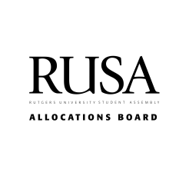Special Events Funding 2021-2022

RUSA Allocations Board

4 November 2021

**01 02 03 04**

An annual event that has been funded as a Special Event at least three times in the past five years.

Must have at least one co-sponsorship from an academic or administrative department or outside company. This co-sponsorship must be equal to or greater than 20% of the proposed total cost of the event.

A total event cost of over $17,000.00 and accommodating a minimum of 250 people.

Co-sponsorship by seven or more campus groups.

What makes a Special Event?

Applications open from September 6th to October 18th

Special Events Hearing held on October 25th

Funding decisions sent out by October 30th

Application Process

All applications for Special Events go through GetInvolved

Clubs were given 20 minutes to present and discuss their budgets in detail All unfundable items were removed from proposed budgets

All eligible events were funded and received a 10% year-on-year increase from their last in-person hosting. Clubs must demonstrate well-planned event with detailed cost breakdowns Funding decisions are not based on content, but solely on how prepared a club is to conduct their event.

Special

Events

Hearing

9 student organizations were invited to the Special Events hearing to present their budgets.

This Year's Budget

We have had the ability to increase the budget for Special Events this year due to substantial takebacks that took place during the 2020-2021 academic year.

**$144,109**

Special Events Budget (+23.8% from last year)

**$28,500**

Security Budget

Funding Breakdown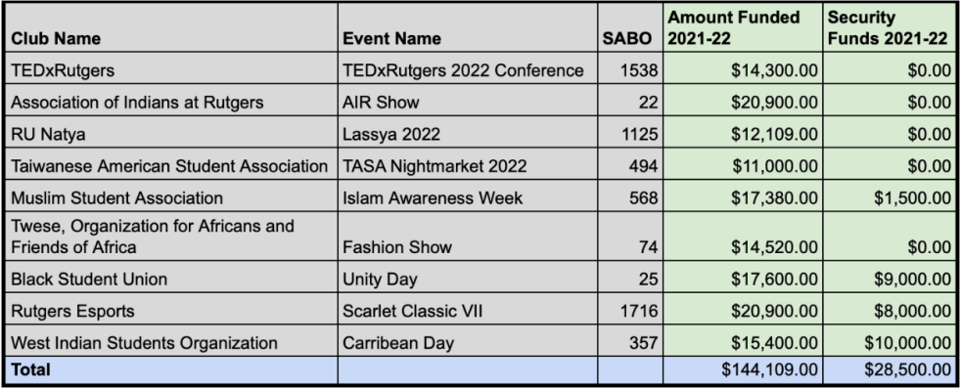

Funding

Breakdown

WISO

10.7%

Esports

14.5%

BSU

12.2%

TEDxRutgers

9.9%

AIR

14.5%

RU Natya

8.4%

(Excluding Security)

Twese 10.1%

MSA 12.1%

TASA 7.6%

Summary

Special Events are unique annual events that are important to the Rutgers comminuty and require substantial funding due to their size.

The qualification process for Special Events is rigorous and requires demonstrated ability to host an event of such size.

We have increased our budget for Special Events substantially but sustainiably to promote an upward trend of funding in the coming years.

**01 02 03**

Questions?

rusa.allocations@gmail.com Evan - (908)216-9450